# Office Networking Design

A COURSE PROJECT REPORT

By

# Pranay Venket Bhrammadipati (RA1911003010558)

# Anurag Sharma (RA1911003010551)

# Ritika Gupta (RA1911003010524)

Under the guidance of **Subject Handling Faculty Name** *In partial fulfilment for the Course*

of

18CSC302J - COMPUTER NETWORKS

in Department Name



# FACULTY OF ENGINEERING AND TECHNOLOGY SRM INSTITUTE OF SCIENCE AND TECHNOLOGY

**Kattankulathur, Chenpalpattu District**

NOVEMBER 2021

**SRM INSTITUTE OF SCIENCE AND TECHNOLOGY**

**(Under Section 3 of UGC Act, 1956)**

**BONAFIDE CERTIFICATE**

# Certified that this project report " Office Networking Design" is the bonafide work of Pranay Venket Bhrammadipati (RA1911003010558), Anurag Sharma (RA1911003010551), Ritika Gupta (RA1911003010524)

# who carried out the project work under my supervision.

# SIGNATURE SIGNATURE

Dr.R.Yamini **Dr.E. Sasikala,**

# Assistant Professor (OG) Course Cordinator

**Computer Science Department Associate Professor,**

SRM Institute of Science and Technology **Data Science and Business Systems** Potheri, SRM Nagar, Kattankulathur, SRM Institute of Science and Technology Tamil Nadu 603203 Potheri, SRM Nagar, Kattankulathur,

Tamil Nadu 603203

# ABSTRACT

Internal and external networks especially for an organization is very important, yet it may be flawed due to poor configuration of the design. So our project’s aim is to design a proper and useful network design for a small office for effective communication between the office employees within the office and even outside.

**Group members:**

Ritika Gupta (RA1911003010524)

Anurag Bhamidipati (RA1911003010551)

Pranay Bhamidipati (RA1911003010558)

# ACKNOWLEDGEMENT

We express our heartfelt thanks to our honorable **Vice Chancellor Dr. C. MUTHAMIZHCHELVAN**, for being the beacon in all our endeavors.

We would like to express my warmth of gratitude to our **Registrar Dr. S. Ponnusamy,** for his encouragement

We express our profound gratitude to our **Dean (College of Engineering and Technology) Dr. T. V.Gopal,** for bringing out novelty in all executions.

We would like to express my heartfelt thanks to Chairperson, School of Computing **Dr. Revathi Venkataraman,** for imparting confidence to complete my course project

We wish to express my sincere thanks to **Course Audit Professor Dr.M.LAKSHMI, Professor and Head, Data Science and Business Systems** and **Course Cordinator Dr.E. Sasikala, Associate Professor, Data Science and Business Systems** for their constant encouragement and support.

We are highly thankful to our my Course project Internal guide **Subject handling staff** Dr.R.Yamini**,** Assistant Professor (OG)**, Computer Science Department,** for ourassistance, timely suggestion and guidance throughout the duration of this course project.

We extend my gratitude to **Student HOD name Department** and my Departmental colleagues for their Support.

Finally, we thank our parents and friends near and dear ones who directly and indirectly contributed to the successful completion of our project. Above all, I thank the almighty for showering his blessings on me to complete my Course project

# TABLE OF CONTENTS

## CHAPTERS CONTENTS PAGE NO.

* + - 1. **ABSTRACT**

## INTRODUCTION

## CLI CODING

## STATIC ROUTING

## FINAL CONNECTIONS

## ADDRESS CONNECTIONS

* + - 1. **REQUIREMENT ANALYSIS**

## ARCHITECTURE & DESIGN

* + - 1. **IMPLEMENTATION**

## EXPERIMENT RESULTS & ANALYSIS

* + - * 1. RESULTS
        2. RESULT ANALYSIS
        3. CONCLUSION & FUTURE WORK

## REFERENCES

# ABSTRACT

Internal and external networks especially for an organization is very important, yet it may be flawed due to poor configuration of the design. So our project’s aim is to design a proper and useful network design for a small office for effective communication between the office employees within the office and even outside.

**Group members:**

Ritika Gupta (RA1911003010524)

Anurag Bhamidipati (RA1911003010551)

Pranay Bhamidipati (RA1911003010558)

1. **INTRODUCTION**
   1. **Topology**

This is star Topology in this small office network in which there is a main connection router in center of the server, Figure 1.1 shows how the connection looks:-

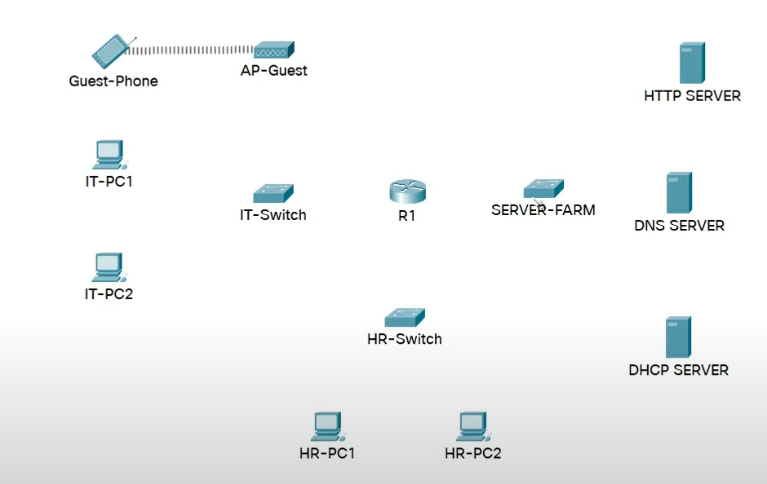

**Figure 1.1(Basic Network layout)**

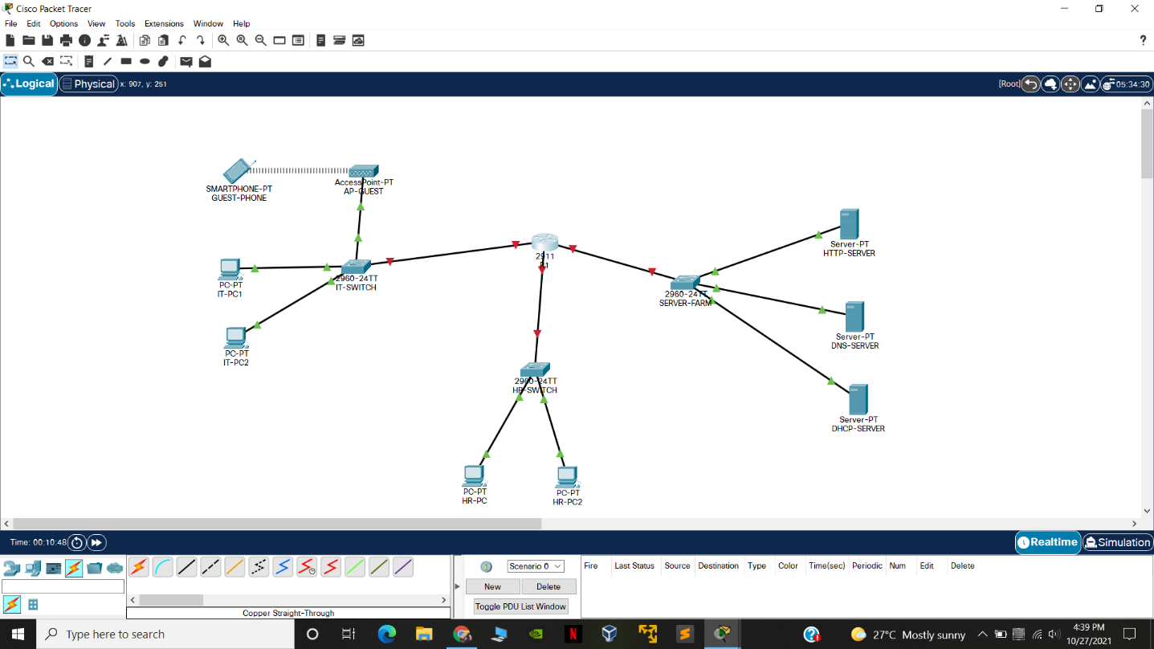

**Figure 1.2(in process Network)**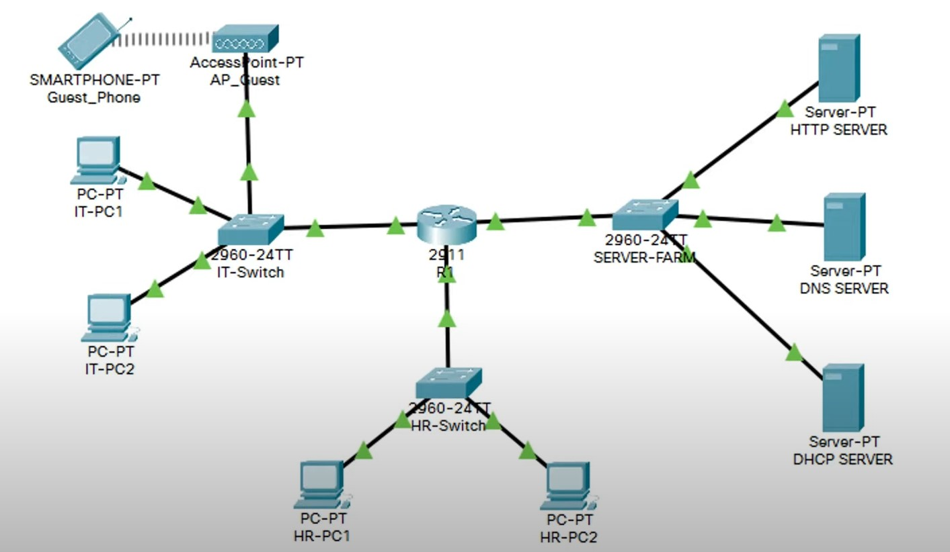

**Figure 1.3(Final Output)**

1. **CLI Coding** 
   1. For router

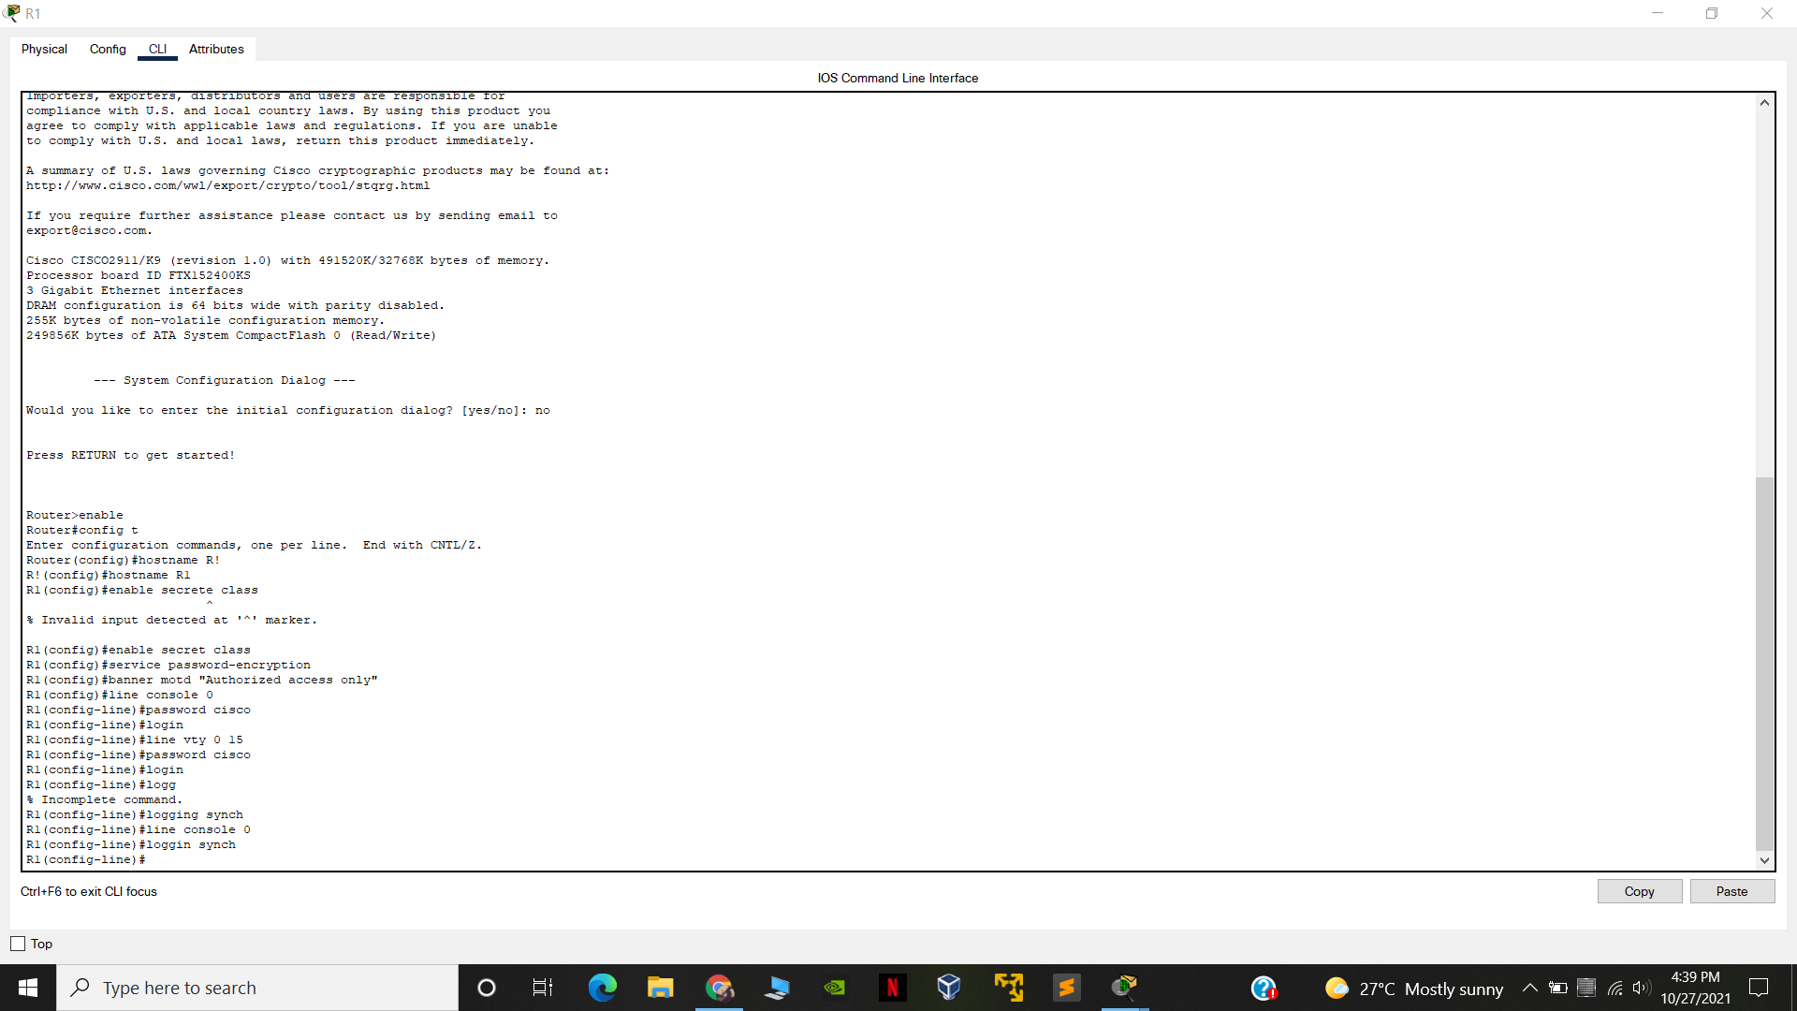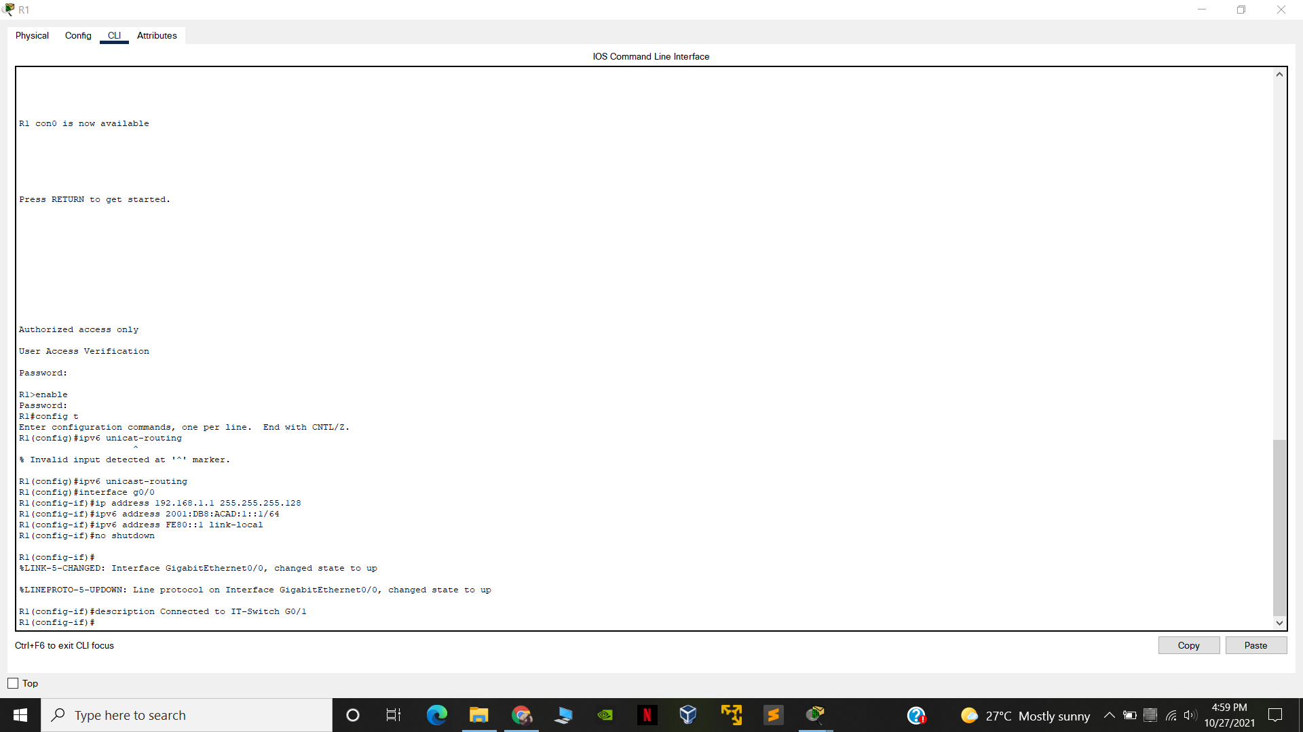

Figure 1.4 (CLI for R1)

* 1. HR Switch CLI

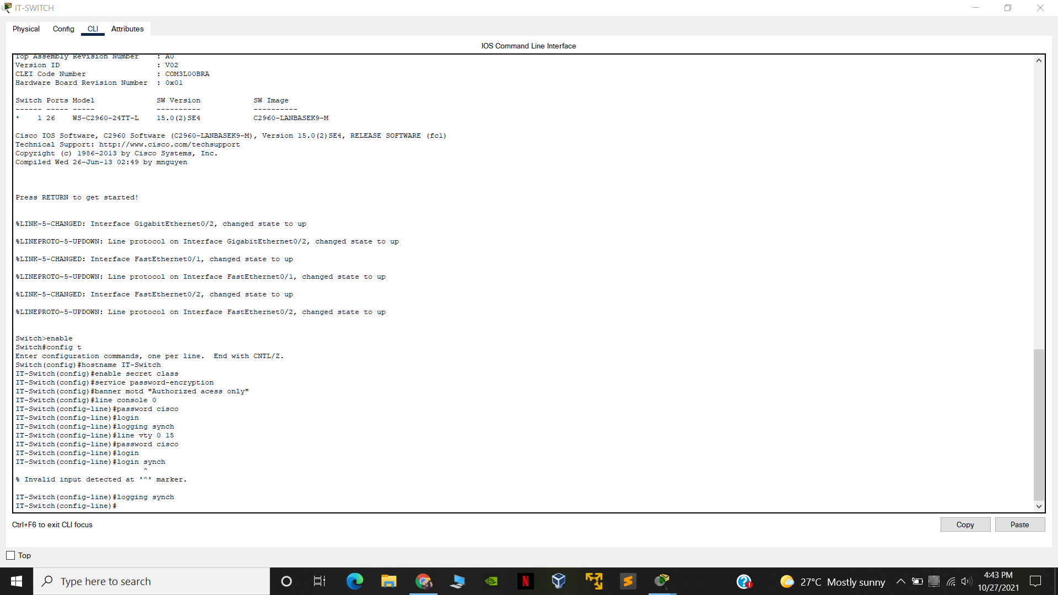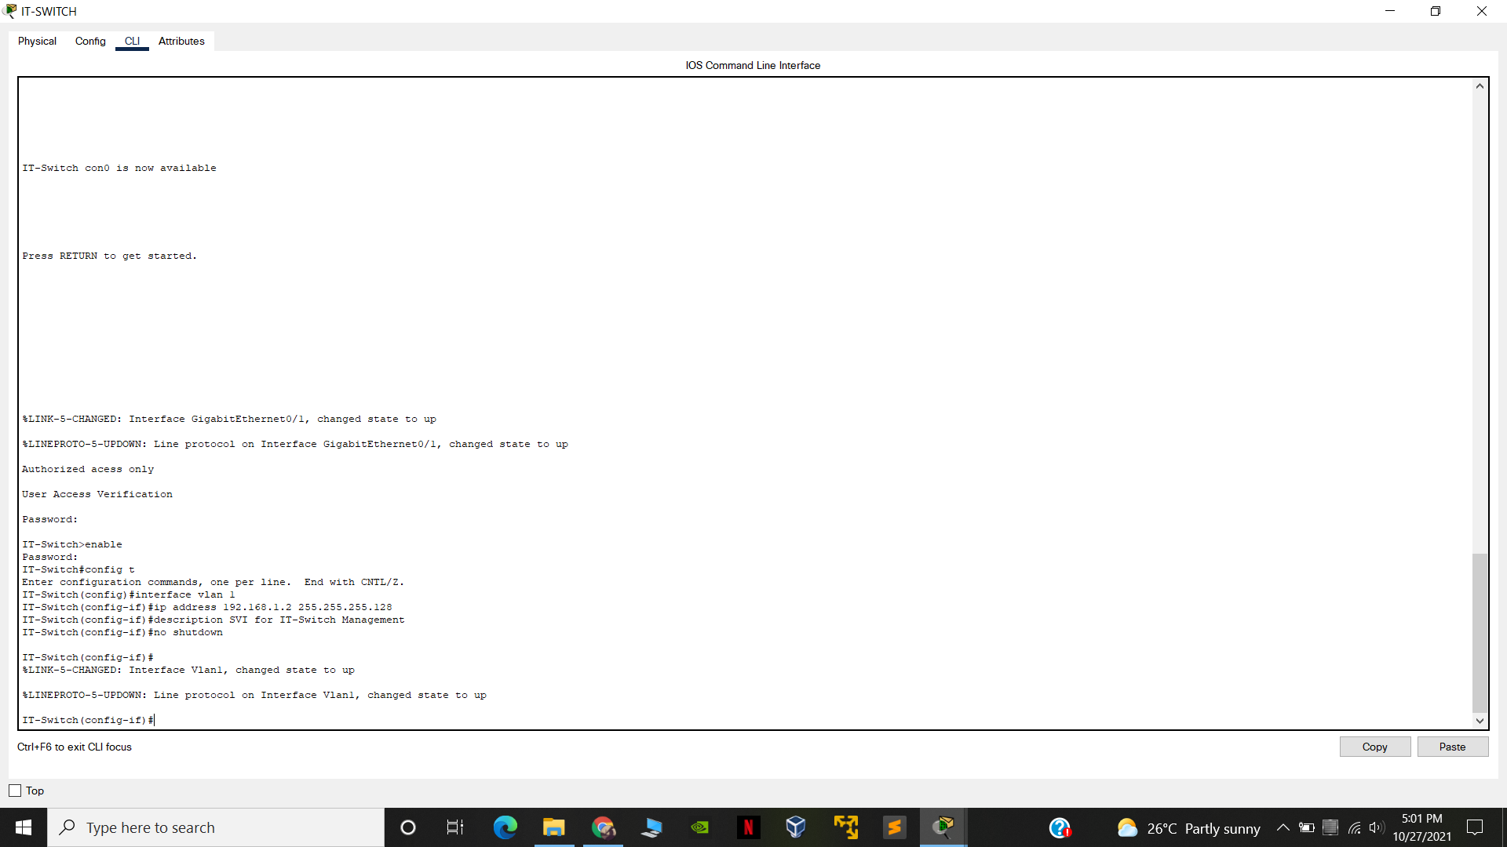

* 1. HR Switch CLI

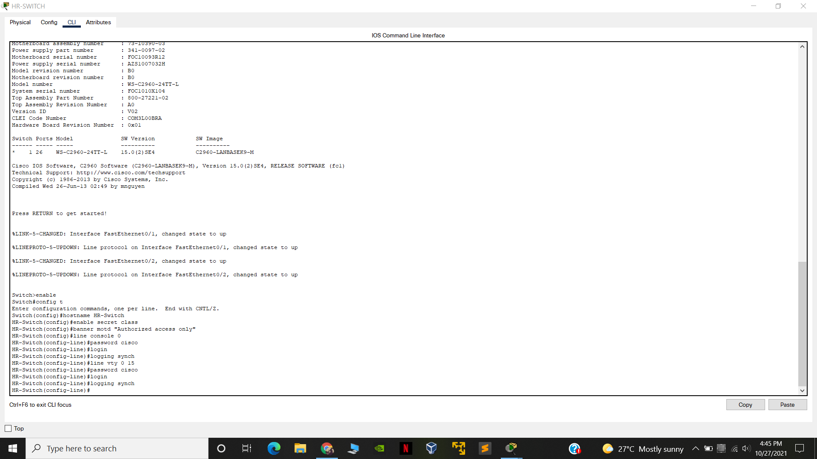

* 1. SERVER Farm CLI commands

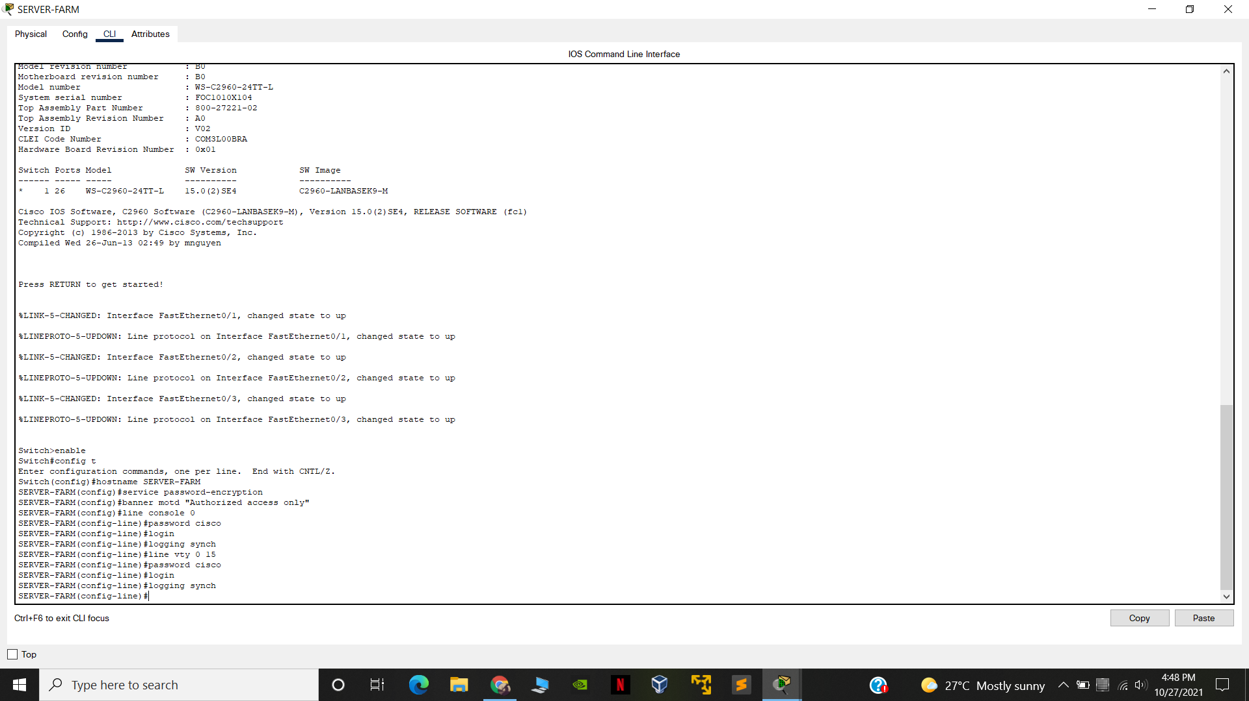

1. **Static Routing**
   1. Static routing IT pc1

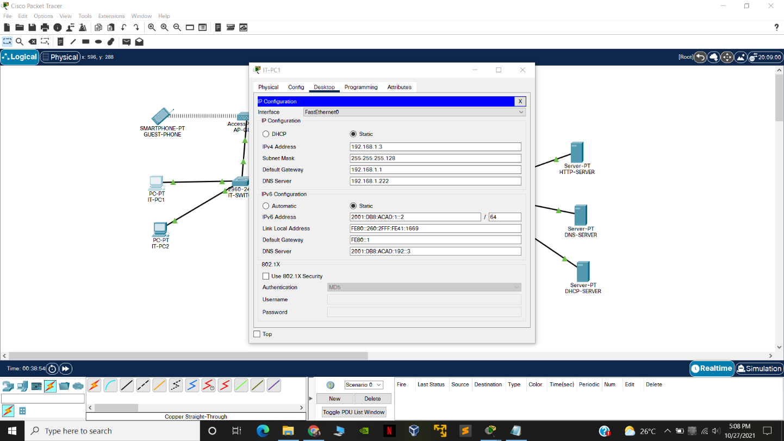

* 1. IT Pc 2

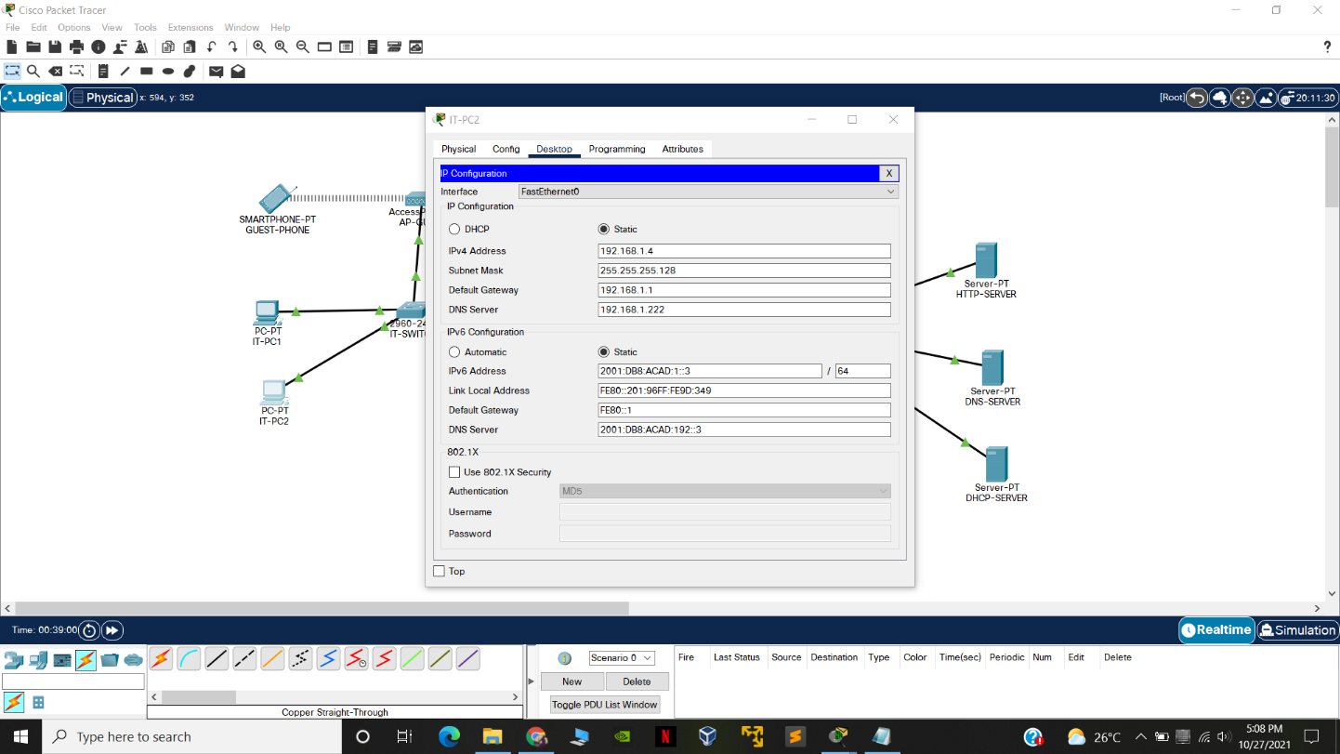

* 1. Guest Phone

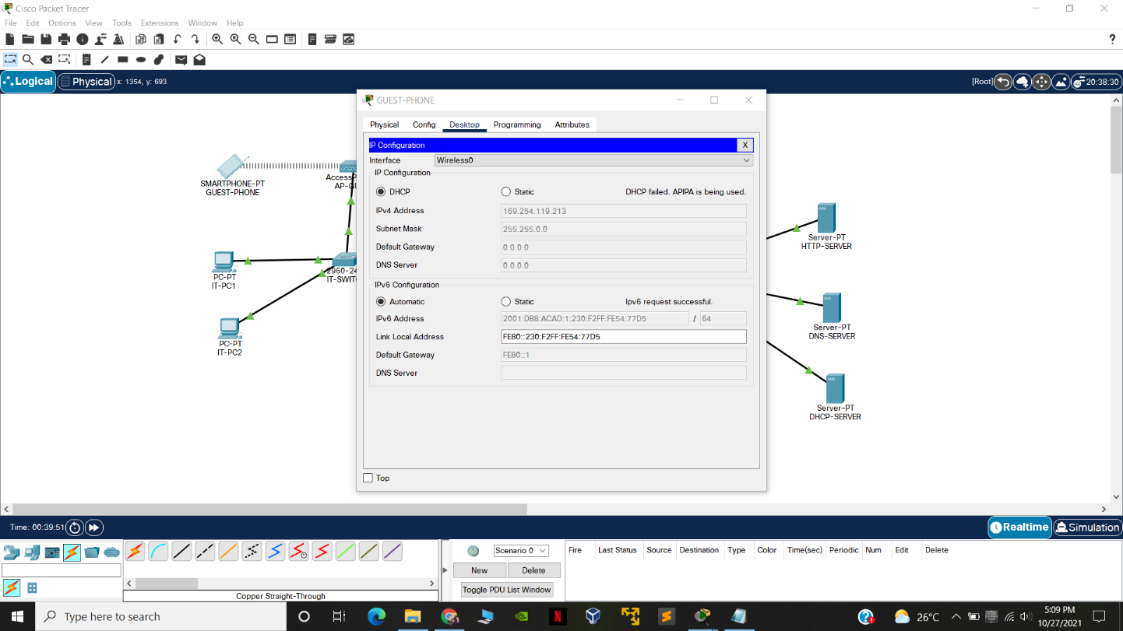

1. **Connections to Router Via CLI commands**
   1. CLI for router

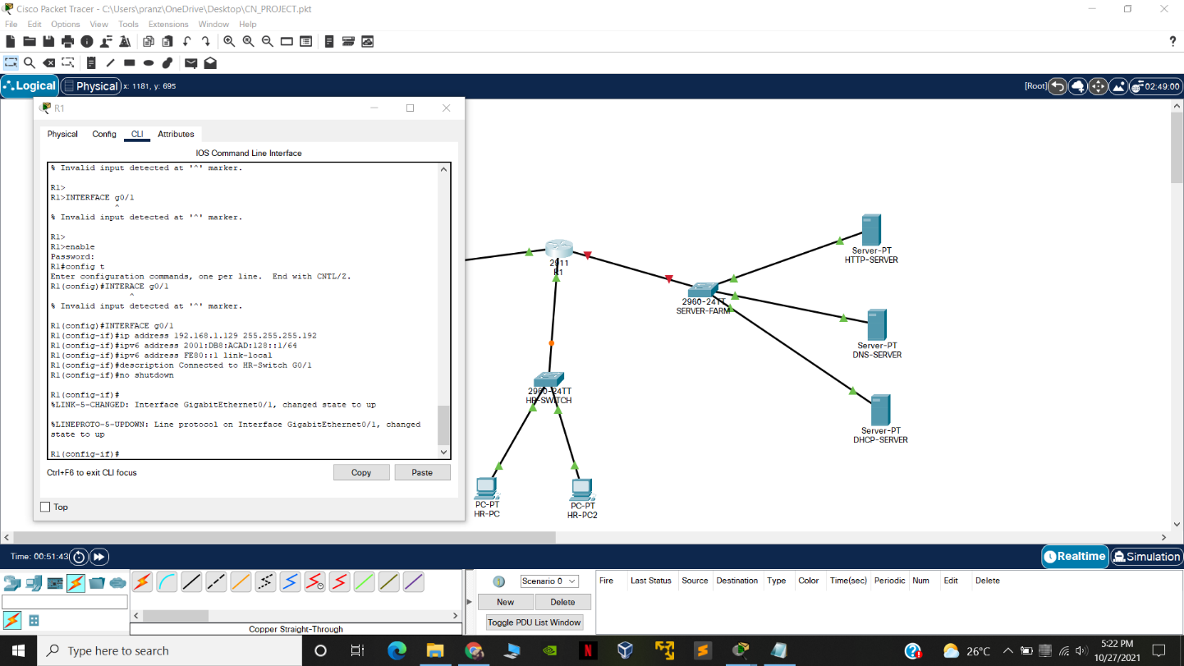

* 1. HR switch CLI commands

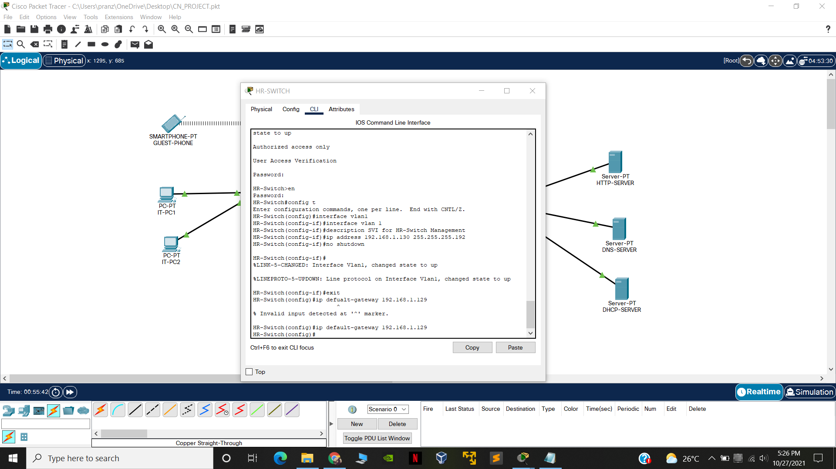

* 1. HR pc2 static routing

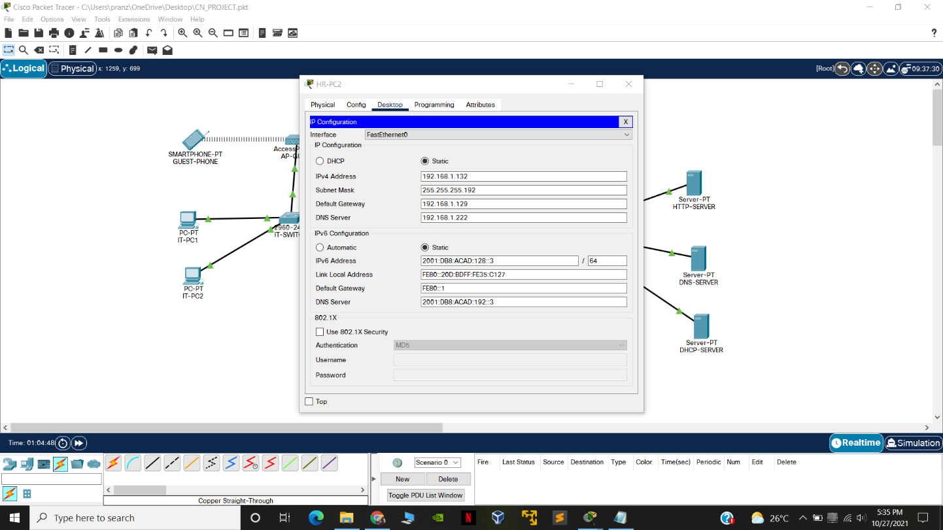

* 1. HR pc 1 Static routing

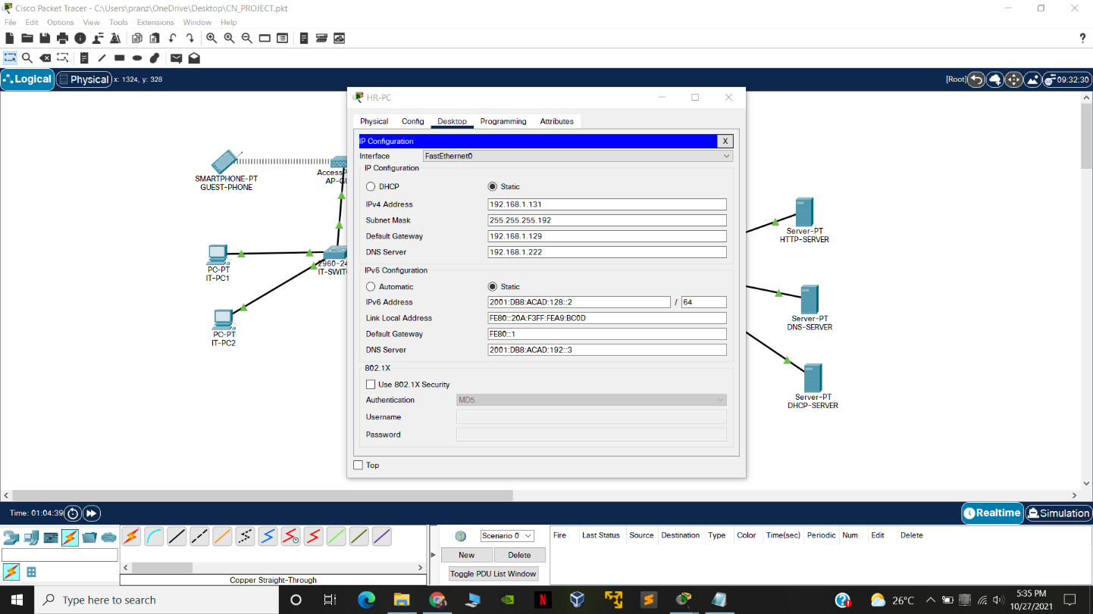

* 1. R1 connection for Server Farm

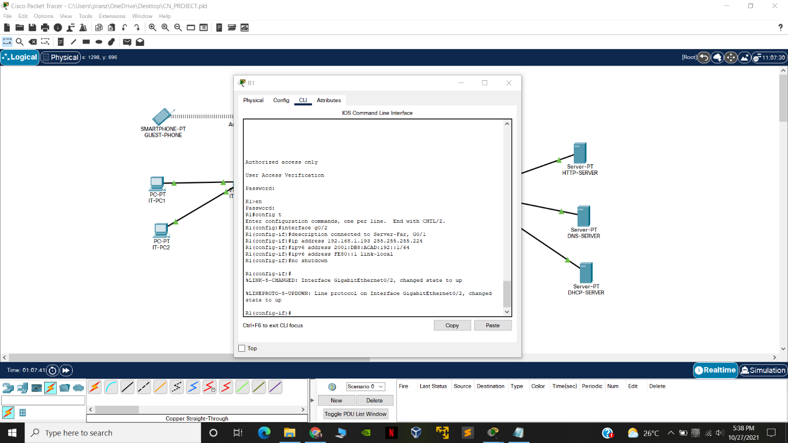

* 1. Sever farm connection with router

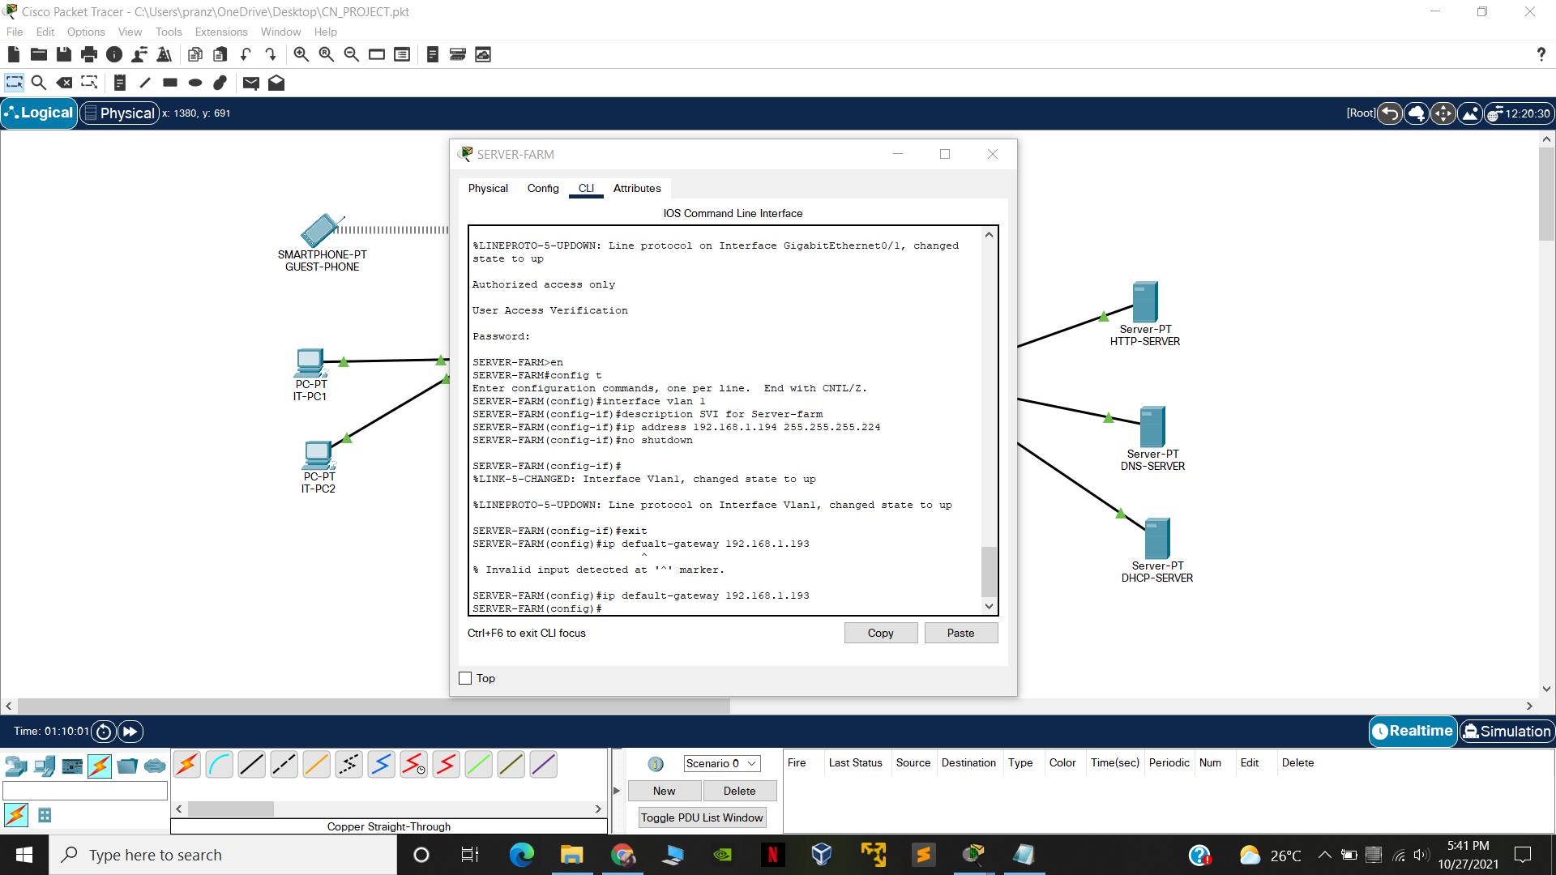

* 1. HTTP Server connection



* 1. DNS Server connection

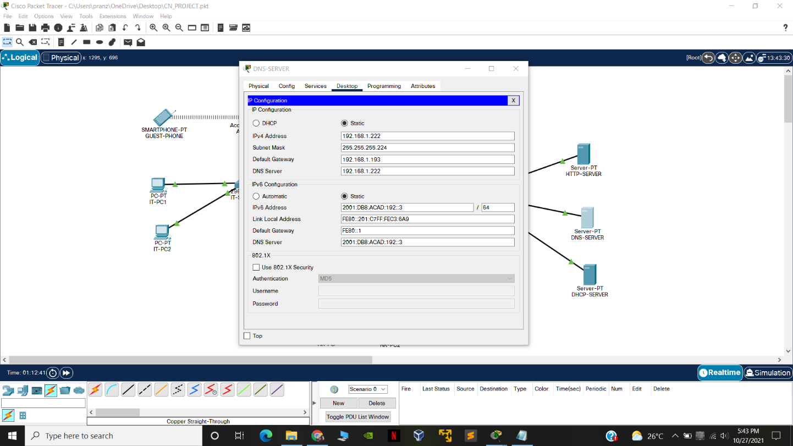

* 1. DHCP server connection

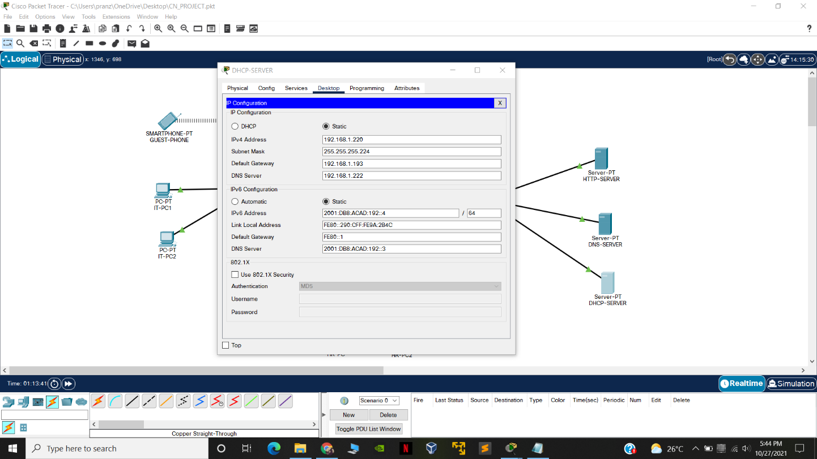

1. **Final CheckUp**

HTTP Server test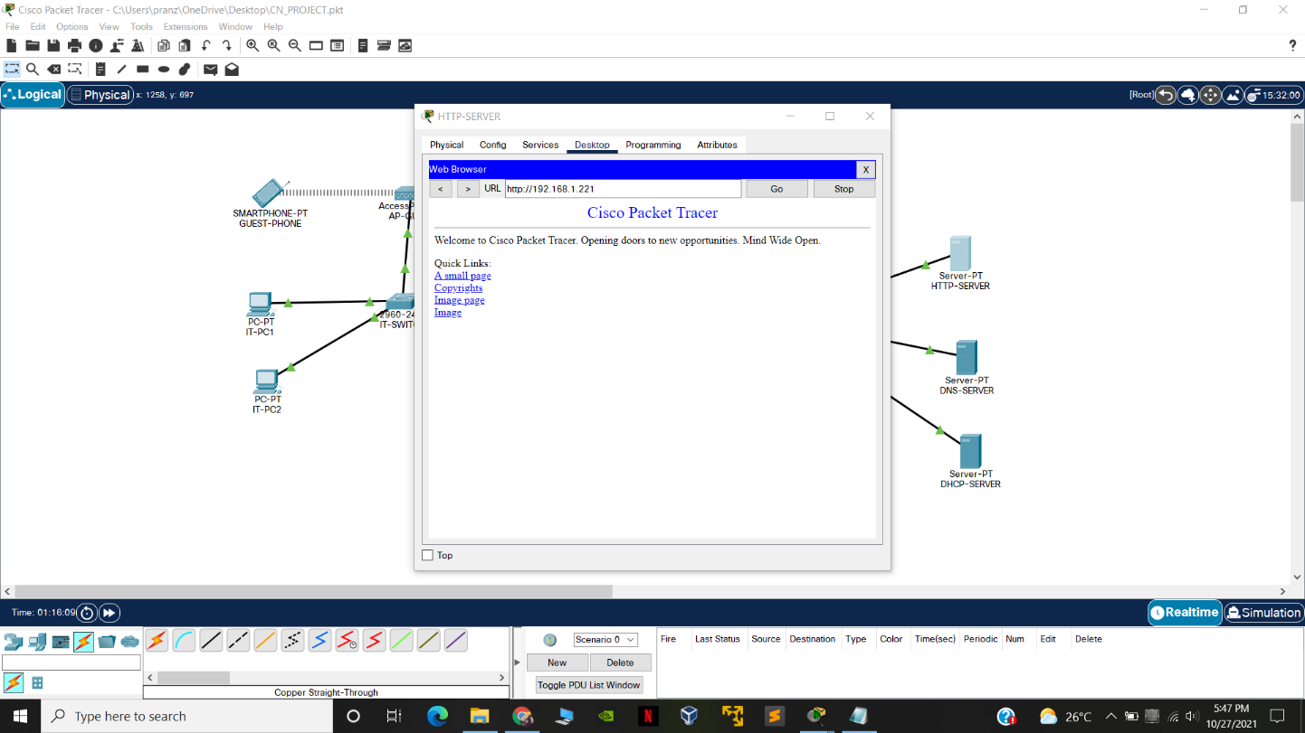

Adding dns Address

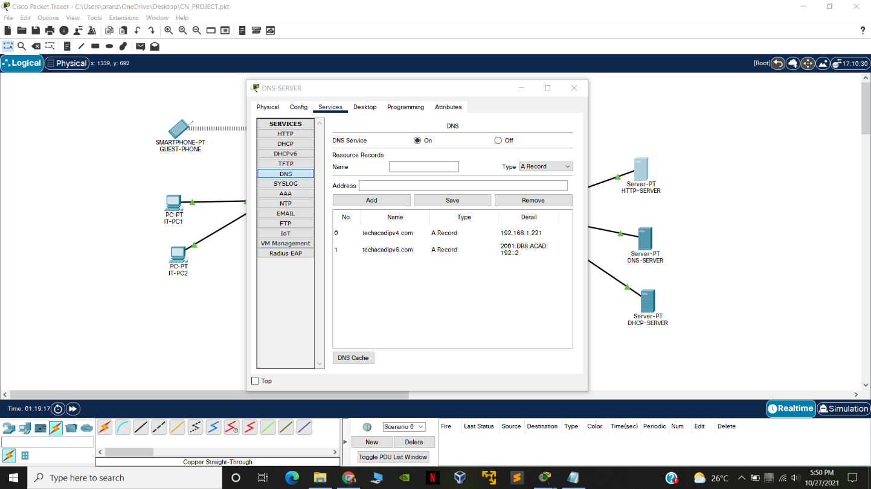

Adding DHCP Connection

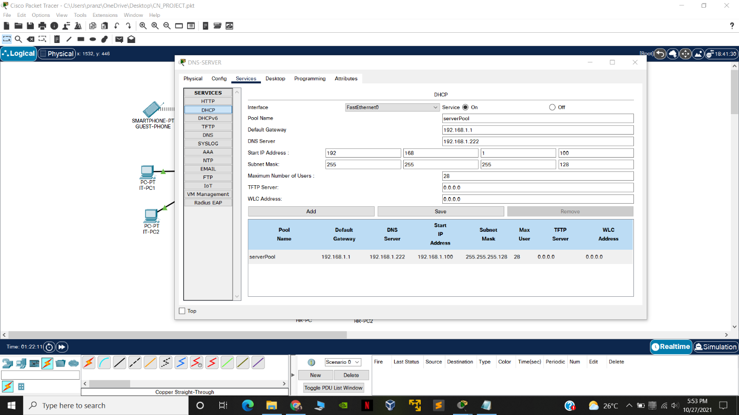

Adding final connection

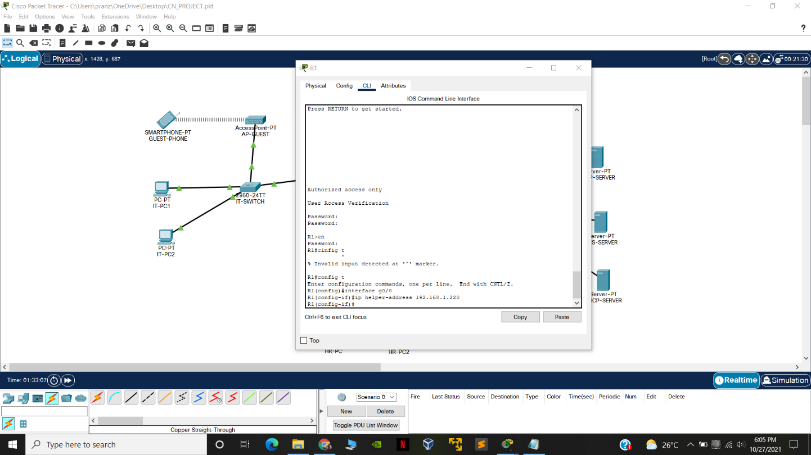

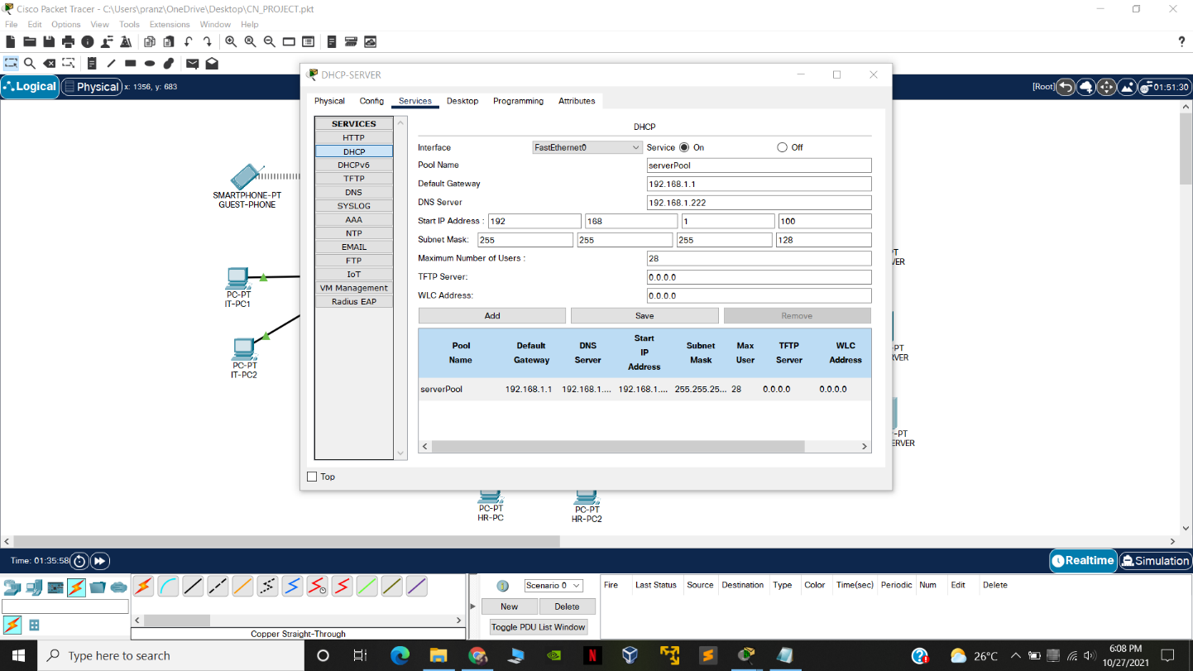

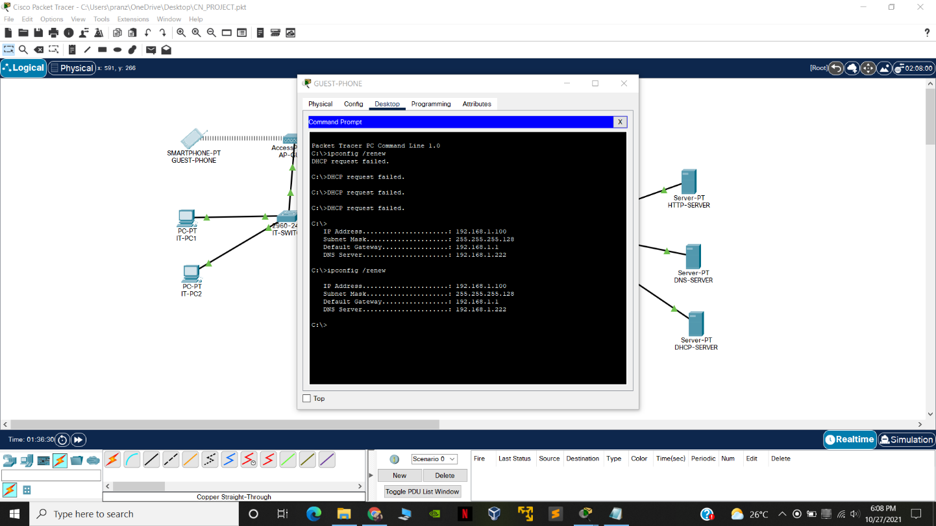

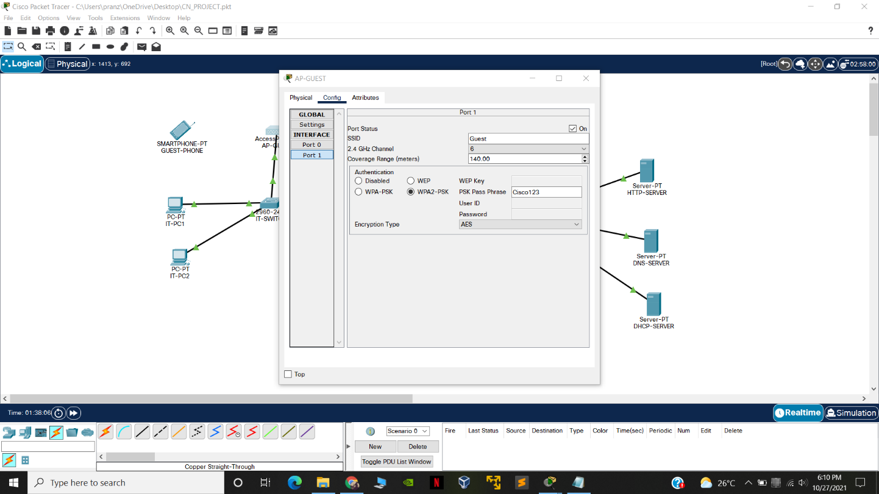

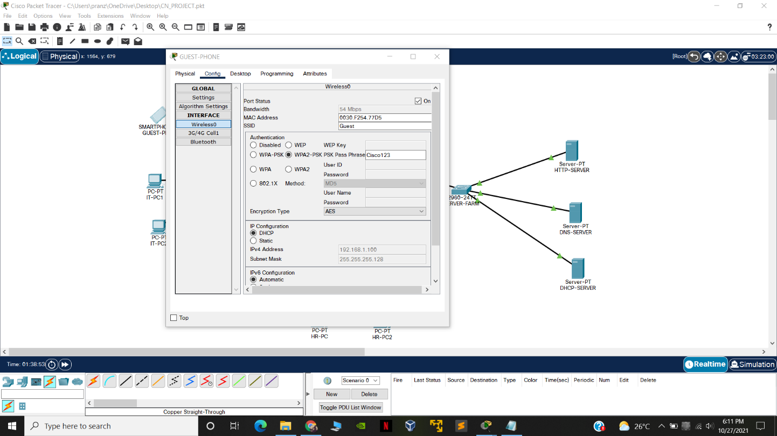

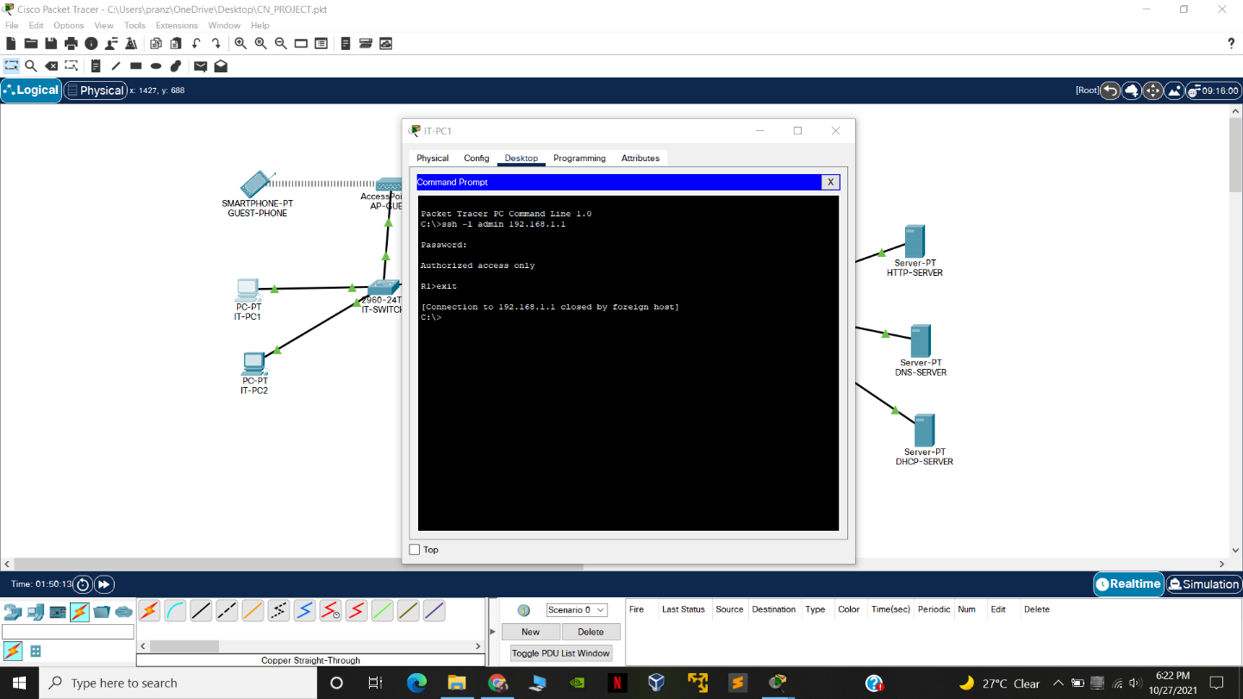

1. **ADDRESSING TABLES**

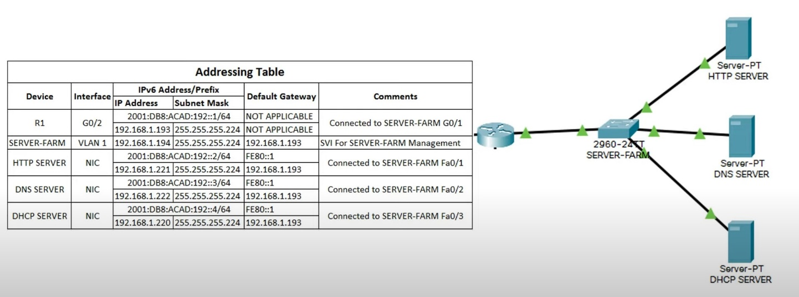

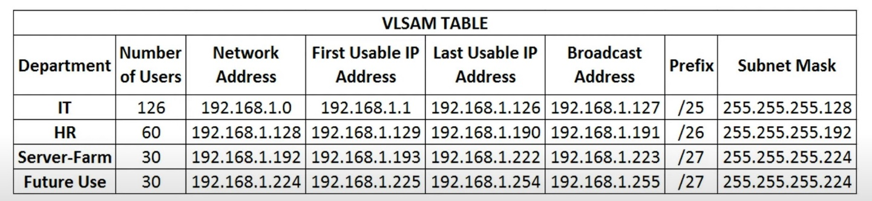

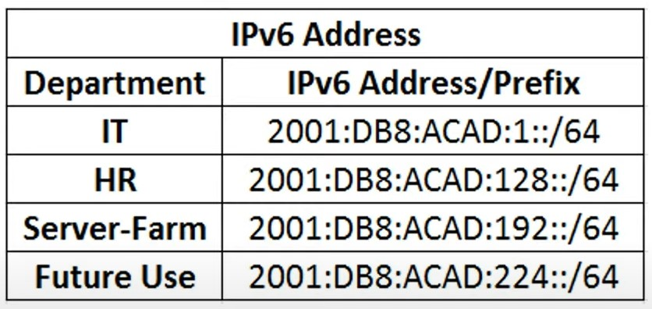

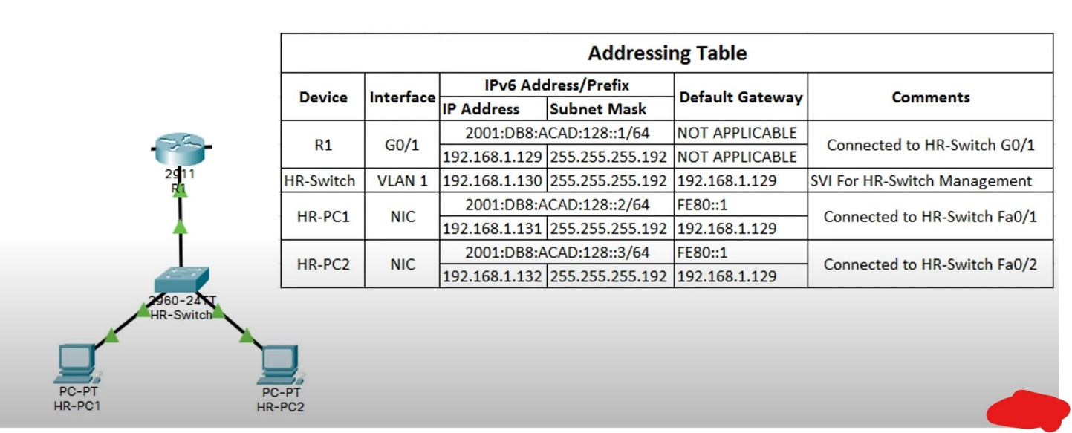

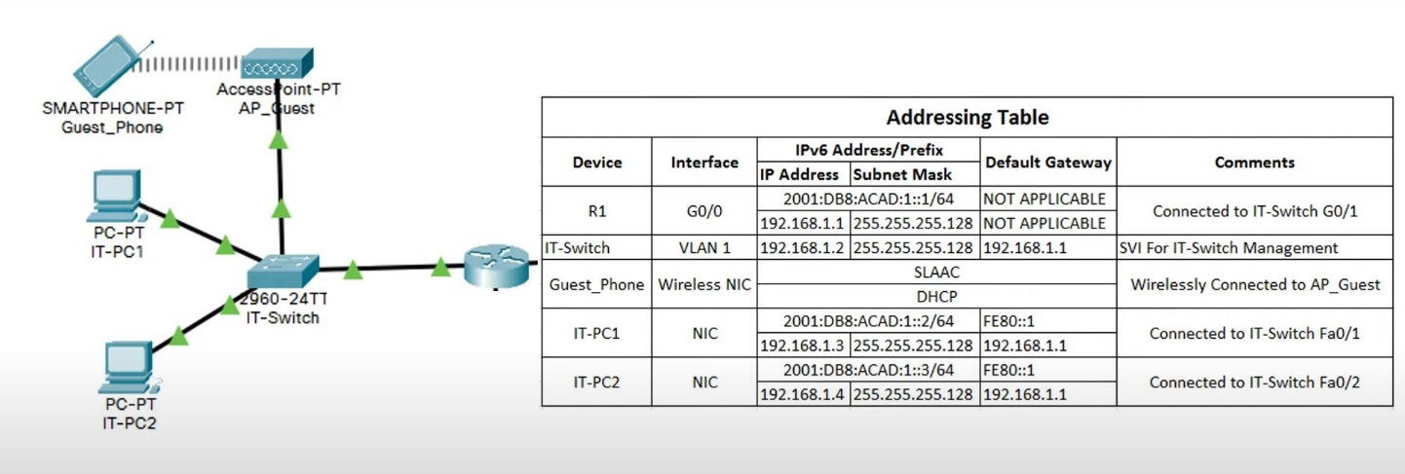

1. **REQUIREMENT ANALYSIS**

|  |  |  |
| --- | --- | --- |
| **S.NO** | **MODEL NUMBER** | **QUANTITY** |
| **1** | **2911 router** | **1** |
| **2** | **2960-24TT** | **3** |
| **3** | **Server-PT** | **3** |
| **4** | **PC (end node)** | **4** |
| **5** | **Access Point** | **1** |
| **6** | **SMARTPHONE** | **1** |

1. **ARCHITECTURE & DESIGN**

This system is based on Star topology: - Star topology is a network topology in which each network component is physically connected to a central node such as a router, hub or switch.

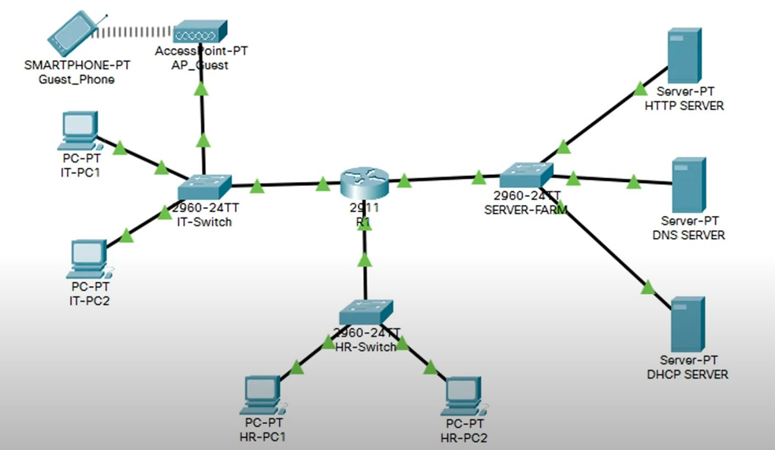

1. IMPLEMENTATION

The process starts with introduction process in which the network is designed and we chose star topology and proceed the netwok drsign of the Office network then we proceed with thw components.

Then the IT,HR and server farm in which the configuration in which we add end nodes and the it server is connected to the switch which used by any guest connected to it.

Then we proceed with thw cli coding and the static connection of all the routers and the end nodes with assigning them there IP address .



## EXPERIMENT RESULTS & ANALYSIS

## The results were on the basis of experements performedLike test for end to end connectivity using the guest smartphone with the url <https://randomnameip4.com> which shows this

## And then the next test is about the ssh connection via IP address

## 

## Then the connection is established via entering the password

## 

## 

## Hence we have assurity that the system was connected in every aspect and was protected by a password.

## REFERNCES

## <https://www.techopedia.com/definition/13335/star-topology#:~:text=Star%20topology%20is%20a%20network,connecting%20nodes%20act%20like%20clients.&text=A%20star%20topology%20is%20also%20known%20as%20a%20star%20network>.

## <https://community.cisco.com/t5/switching/server-farm-switch/td-p/1066188>

## <https://www.youtube.com/watch?v=gUbDd3oD598>